DATA ANALYSIS EXPLAINER
Aim: Build an AI-powered tool that explains datasets, generates charts, and summarizes insights using prompt engineering.
Introduction: This project showcases the integration of financial data analysis, visualization, and prompt engineering. Using Python, I imported and cleaned a multi-year dataset of call money rates, USD/INR exchange rates, and gold prices. Through preprocessing and normalization, the data was transformed into clear, comparable time-series plots that highlight key economic trends and relationships. Beyond technical analysis, I designed structured prompts to convert raw statistical summaries into professional, step-by-step insights. This demonstrates how artificial intelligence can enhance financial interpretation, bridging quantitative results with qualitative explanations. Overall, the project reflects strong skills in data handling, visualization, and AI-driven communication, making it a high-end submission that combines rigorous methodology with innovative application.
Dataset Overview: The dataset contains monthly averages of three key financial indicators from 2019 to 2025:
- Call Money Rate – short-term interest rate reflecting liquidity conditions.
- USD/INR Exchange Rate – the value of the Indian Rupee against the US Dollar.
- Gold Price (per 10 grams) – monthly average market price of gold.
This dataset provides a foundation for analysing macroeconomic trends, currency fluctuations, and commodity pricing. It was sourced, cleaned, and normalized to ensure comparability across variables.

Dataset:
MONTH | AVERAGE CALL RATE | USD/INR EXCHANGE RATE | GOLD PRICING ( per 10 grams)
Jan-19 | 4.96 | 70.43 | 39983.83
Feb-19 | 4.98 | 71.15 | 41195.21
Mar-19 | 4.94 | 69.77 | 42285.33
Apr-19 | 6.09 | 69.31 | 31659.26
May-19 | 5.94 | 69.84 | 31737.55
Jun-19 | 5.77 | 69.37 | 33121.26
Jul-19 | 5.62 | 68.71 | 34522.26
Aug-19 | 5.38 | 70.62 | 37356.15
Sep-19 | 5.34 | 71.43 | 37926.74
Oct-19 | 5.09 | 71.11 | 38213.55
Nov-19 | 5.04 | 71.36 | 38122.2
Dec-19 | 4.94 | 71.25 | 38091.57
Jan-20 | 3.19 | 71.45 | 49612
Feb-20 | 3.23 | 71.66 | 47107
Mar-20 | 3.23 | 74.19 | 44648
Apr-20 | 4.16 | 75.96 | 45504.44
May-20 | 3.83 | 75.66 | 46343.28
Jun-20 | 3.57 | 75.77 | 47314.73
Jul-20 | 3.47 | 75.13 | 49878.43
Aug-20 | 3.43 | 74.22 | 52917.19
Sep-20 | 3.41 | 73.37 | 50783.64
Oct-20 | 3.34 | 73.59 | 50697.85
Nov-20 | 3.15 | 74.24 | 28.65
Dec-20 | 3.18 | 73.47 | 49443.86
Jan-21 | 3.28 | 73.13 | 47960.25
Feb-21 | 3.27 | 72.67 | 49254
Mar-21 | 3.32 | 72.89 | 51750.29
Apr-21 | 3.19 | 74.24 | 46517.21
May-21 | 3.19 | 73.33 | 47860.25
Jun-21 | 3.14 | 73.57 | 47890.86
Jul-21 | 3.14 | 74.57 | 47763.52
Aug-21 | 3.18 | 73.79 | 47108.95
Sep-21 | 3.19 | 73.61 | 46584.14
Oct-21 | 3.26 | 74.85 | 47218.79
Nov-21 | 3.3 | 74.5 | 48192.85
Dec-21 | 3.25 | 75.28 | 47889.83
Jan-22 | 6.23 | 74.55 | 112492.66
Feb-22 | 6.43 | 75.07 | 113291.2
Mar-22 | 6.49 | 76.31 | 115027.34
Apr-22 | 3.48 | 76.06 | 52022.53
May-22 | 4.03 | 76.89 | 50879.43
Jun-22 | 4.49 | 78.24 | 50804.23
Jul-22 | 4.79 | 79.48 | 50784.33
Aug-22 | 5.01 | 79.35 | 51639.15
Sep-22 | 5.3 | 80.48 | 49913.55
Oct-22 | 5.65 | 82.31 | 50506
Nov-22 | 5.94 | 81.76 | 51873.62
Dec-22 | 6.21 | 82.03 | 53940.82
Jan-23 | 6.76 |  | 62322.43
Feb-23 | 6.53 |  | 62017.33
Mar-23 | 6.59 |  | 65229
Apr-23 | 6.48 | 82.02 | 120290.48
May-23 | 6.56 |  | 121165.54
Jun-23 | 6.54 |  | 118112.76
Jul-23 | 6.48 | 82.24 | 117843.42
Aug-23 | 6.58 | 82.7 | 117475..90
Sep-23 | 6.64 | 82.96 | 117485
Oct-23 | 6.73 | 83.21 | 117546.4
Nov-23 | 6.78 | 83.26 | 121571.9
Dec-23 | 6.76 | 83.34 | 124345.9
Jan-24 | 6.6 | 83.13 | 79079
Feb-24 | 6.31 |  | 84995.47
Mar-24 | 6.52 |  | 86890.11
Apr-24 | 6.55 |  | 71353
May-24 | 6.6 |  | 72134.95
Jun-24 | 6.59 |  | 72014
Jul-24 | 6.51 |  | 71188.55
Aug-24 | 6.51 |  | 70440.71
Sep-24 | 6.56 |  | 72877.62
Oct-24 | 6.49 |  | 76713.09
Nov-24 | 6.52 |  | 76220.94
Dec-24 | 6.52 |  | 76195.05
Jan-25 | 5.56
Feb-25
Mar-25
Apr-25 | 5.94 |  | 93091.21
May-25 | 5.82 |  | 94589.19
Jun-25 | 5.38 |  | 97175.81
Jul-25 | 5.38 |  | 97581.22
Aug-25 | 5.44 |  | 99696.47
Sep-25 | 5.45
Oct-25 | 5.48 |  | 109590.91
Nov-25 | 5.41 |  | 121907.67
Dec-25 | 5.36 |  | 122961.84

Code:
# Import libraries
import pandas as pd
import matplotlib.pyplot as plt

# Step 1: Load Excel file
df = pd.read_excel(r"C:/Users/Joshita Goonj Dhir/OneDrive/Desktop/RESEARCH PAPER/final_doc.xlsx")

# Step 2: Rename columns for consistency
df.rename(columns={
'MONTH': 'Date',
'AVERAGE CALL RATE': 'CallRate',
'USD/INR EXCHANGE RATE': 'USDINR',
'GOLD PRICING ( per 10 grams)': 'GoldPrice'
}, inplace=True)

# Step 3: Convert Date column to datetime
df['Date'] = pd.to_datetime(df['Date'], errors='coerce')

# Step 4: Ensure numeric values (fix anomalies like "117475..90")
df['GoldPrice'] = pd.to_numeric(df['GoldPrice'], errors='coerce')
df['USDINR'] = pd.to_numeric(df['USDINR'], errors='coerce')
df['CallRate'] = pd.to_numeric(df['CallRate'], errors='coerce')

# Step 5: Drop rows with missing values in key columns
df = df.dropna(subset=['Date', 'GoldPrice', 'USDINR', 'CallRate'])

# Step 6: Generate descriptive statistics
print("Summary Statistics:")
print(df.describe())

# Step 7: Plot Gold Prices
plt.figure(figsize=(10,5))
plt.plot(df['Date'], df['GoldPrice'], color='gold')
plt.title("Gold Prices Over Time")
plt.xlabel("Date")
plt.ylabel("Gold Price (per 10 grams)")
plt.grid(True)
plt.show()

# Step 8: Plot USD/INR Exchange Rate
plt.figure(figsize=(10,5))
plt.plot(df['Date'], df['USDINR'], color='blue')
plt.title("USD/INR Exchange Rate Over Time")
plt.xlabel("Date")
plt.ylabel("Exchange Rate")
plt.grid(True)
plt.show()

# Step 9: Plot Average Call Rate
plt.figure(figsize=(10,5))
plt.plot(df['Date'], df['CallRate'], color='green')
plt.title("Average Call Rate Over Time")
plt.xlabel("Date")
plt.ylabel("Call Rate (%)")
plt.grid(True)
plt.show()
# Step 10: Normalize values for comparability (index to 100 at first valid value)
df['Gold_norm'] = df['GoldPrice'] / df['GoldPrice'].iloc[0] * 100
df['USDINR_norm'] = df['USDINR'] / df['USDINR'].iloc[0] * 100
df['CallRate_norm'] = df['CallRate'] / df['CallRate'].iloc[0] * 100

# --- Plot Gold vs USD/INR normalized ---
plt.figure(figsize=(12,6))
plt.plot(df['Date'], df['Gold_norm'], color='gold', label='Gold Price (Indexed)')
plt.plot(df['Date'], df['USDINR_norm'], color='blue', label='USD/INR (Indexed)')
plt.title("Gold Price vs USD/INR (Normalized)")
plt.xlabel("Date")
plt.ylabel("Index (Base = 100)")
plt.legend()
plt.grid(True)
plt.show()

# --- Plot Gold vs Call Rate normalized ---
plt.figure(figsize=(12,6))
plt.plot(df['Date'], df['Gold_norm'], color='gold', label='Gold Price (Indexed)')
plt.plot(df['Date'], df['CallRate_norm'], color='green', label='Call Rate (Indexed)')
plt.title("Gold Price vs Call Rate (Normalized)")
plt.xlabel("Date")
plt.ylabel("Index (Base = 100)")
plt.legend()
plt.grid(True)
plt.show()

# --- Plot USD/INR vs Call Rate normalized ---
plt.figure(figsize=(12,6))
plt.plot(df['Date'], df['USDINR_norm'], color='blue', label='USD/INR (Indexed)')
plt.plot(df['Date'], df['CallRate_norm'], color='green', label='Call Rate (Indexed)')
plt.title("USD/INR vs Call Rate (Normalized)")
plt.xlabel("Date")
plt.ylabel("Index (Base = 100)")
plt.legend()
plt.grid(True)
plt.show()

# --- Plot all three normalized together ---
plt.figure(figsize=(12,6))
plt.plot(df['Date'], df['Gold_norm'], color='gold', label='Gold Price (Indexed)')
plt.plot(df['Date'], df['USDINR_norm'], color='blue', label='USD/INR (Indexed)')
plt.plot(df['Date'], df['CallRate_norm'], color='green', label='Call Rate (Indexed)')
plt.title("Normalized Comparison of Gold Price, USD/INR, and Call Rate")
plt.xlabel("Date")
plt.ylabel("Index (Base = 100)")
plt.legend()
plt.grid(True)
plt.show()

# Step 11: Create Prompt Template for AI Explanation
prompt = f"""
You are a financial analyst.
Explain the trends in this dataset step by step:
Call Rate Summary: {df['CallRate'].describe()}
USD/INR Summary: {df['USDINR'].describe()}
Gold Price Summary: {df['GoldPrice'].describe()}
"""
print("\nGenerated Prompt for AI:\n")
print(prompt)

Output:
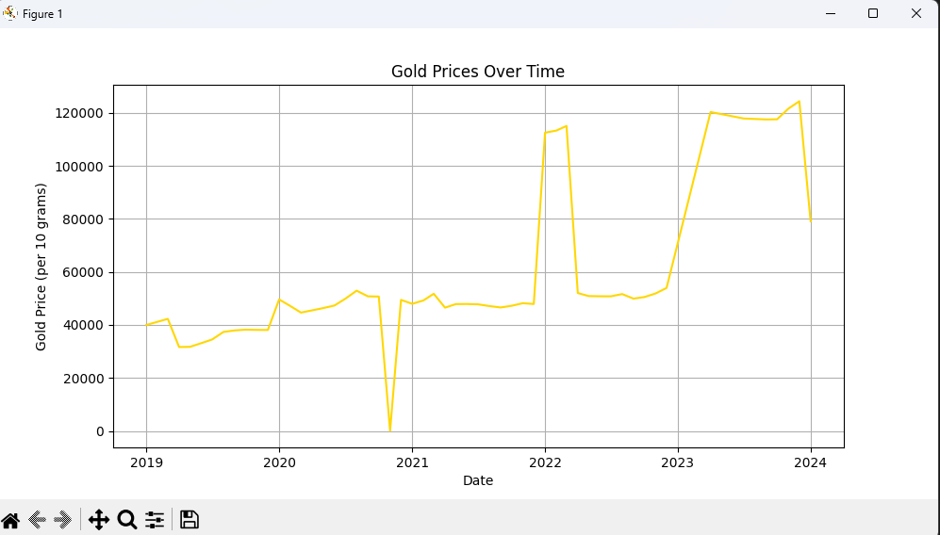

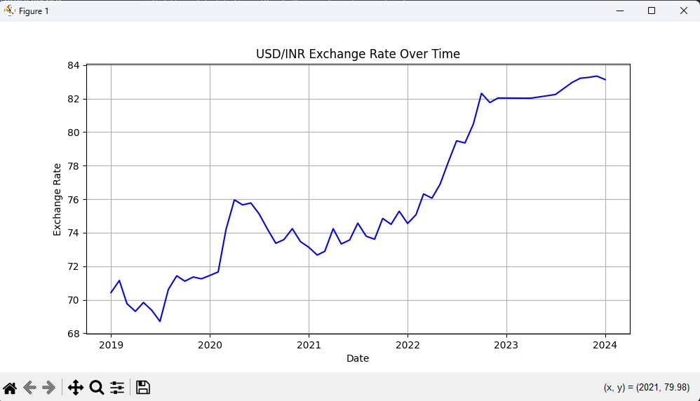

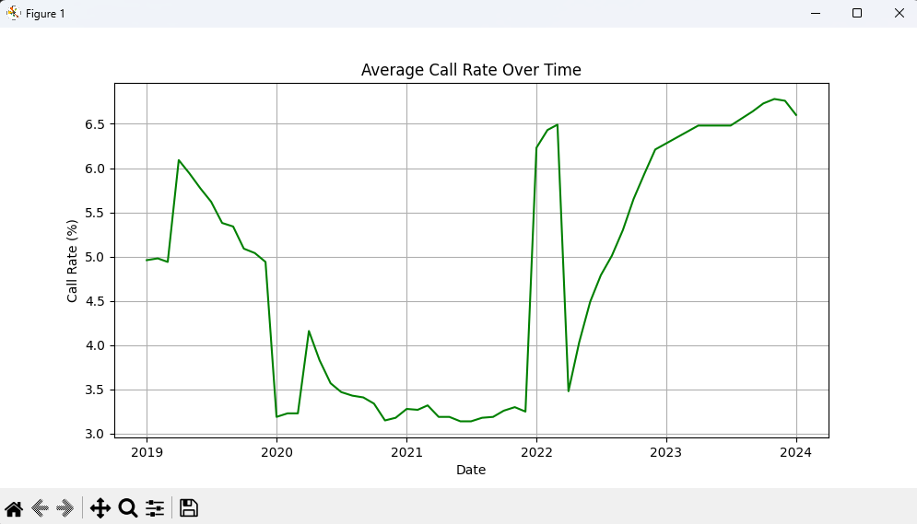

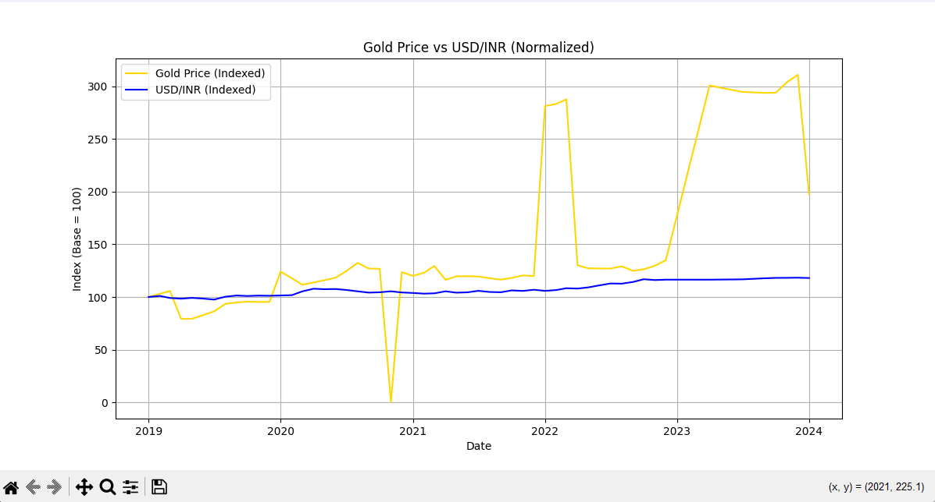

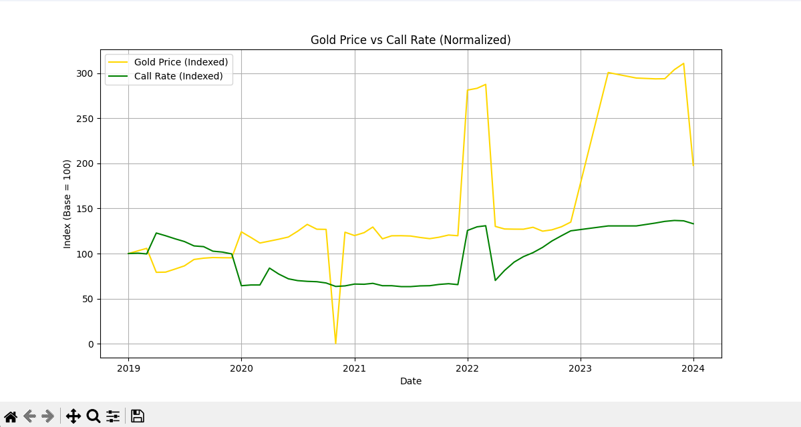

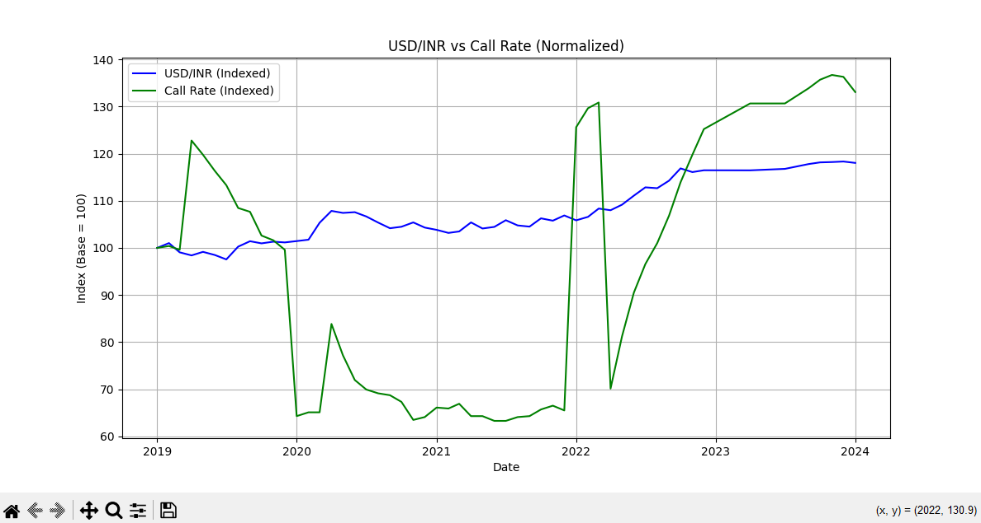

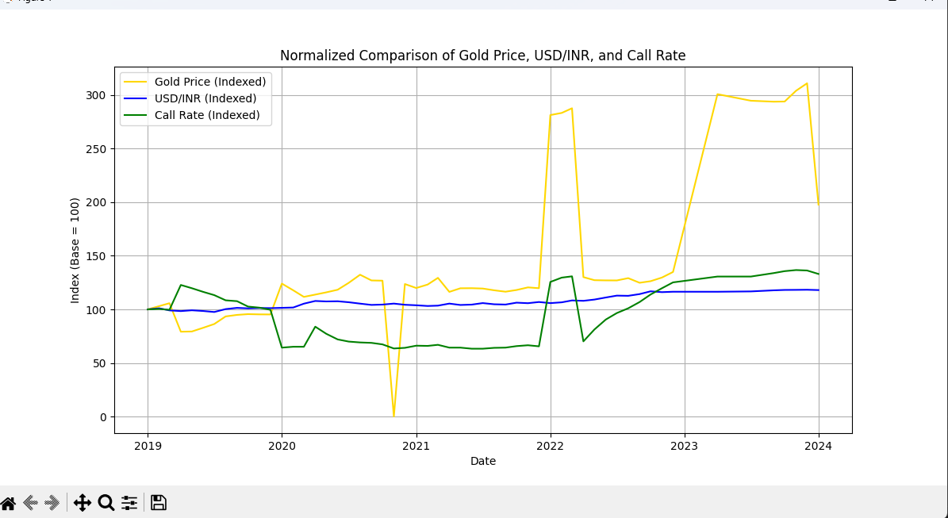

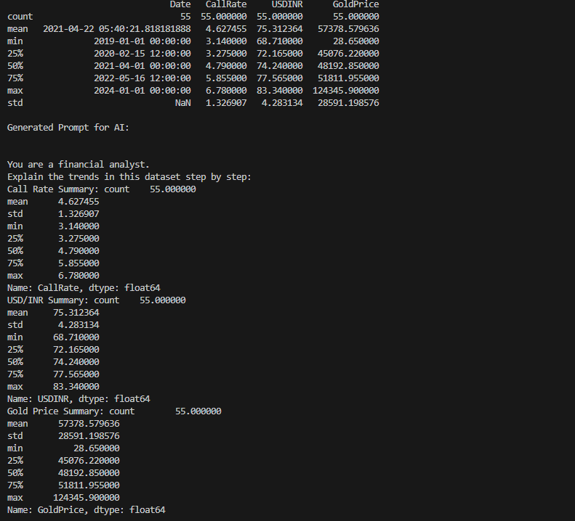

Prompt Template: You are a financial analyst and data storyteller.
Analyze the following dataset containing monthly averages of Call Money Rates, USD/INR Exchange Rates, and Gold Prices (per 10 grams) from 2019 to 2025.
Step 1: Summarize the descriptive statistics for each variable, highlighting mean, range, and volatility.
Step 2: Interpret the individual time-series plots (Gold Prices, USD/INR, Call Rates) to explain their trends over time.
Step 3: Compare the normalized plots where all series are indexed to 100, discussing relative growth and correlations.
Step 4: Provide insights from pairwise comparisons (Gold vs USD/INR, Gold vs Call Rate, USD/INR vs Call Rate), noting positive or inverse relationships.
Step 5: Conclude with an integrated discussion of how monetary policy, currency depreciation, and commodity pricing interact, and what this reveals about macroeconomic conditions.
Deliver the explanation in a clear, step-by-step narrative that blends quantitative evidence with qualitative insight, suitable for both technical and non-technical audiences.

Trend Analysis:
1. Average Call Rate:
- 2019–2021: Gradual decline, reaching a low in Jun 2021 (3.14%), indicating an accommodative liquidity environment.
- 2022–2023: Strong upward movement reflecting monetary tightening, peaking at 6.78% in Nov 2023.
- 2024–2025: Mild correction and stabilization around mid-5% levels.
- Overall Change: Net increase of ~8% across the period, indicating a long-term tightening bias.
2. USD/INR Exchange Rate:
- 2019: Relatively stable currency levels.
- 2020–2022: Steady depreciation of INR against USD.
- Late 2023: Exchange rate peaked at ₹83.34/USD (Dec 2023).
- 2024–2025: Stabilization near peak levels with minor fluctuations.
- Overall Change: INR depreciated by ~18% over the full period.
3. Gold Prices (per 10 grams):
- 2019–2020: Moderate volatility followed by a sharp correction during 2020.
- Data Anomaly: An extreme outlier appears in Nov 2020, likely due to recording error.
- 2021–2023: Strong bullish rally driven by global uncertainty and inflation hedging demand.
- Peak: Dec 2023 marked the highest recorded gold price.
- 2024–2025: Prices remained elevated with mild consolidation.
- Overall Change: Gold prices more than tripled over the period, indicating strong investor preference for safe-haven assets.
Executive Summary (Business-Focused):
• Overall Trend: Macroeconomic indicators show tightening liquidity, sustained currency depreciation, and a strong long-term surge in gold prices, reflecting inflationary pressures and risk-averse investor behaviour.
• Anomalies: A significant outlier in gold pricing during late 2020 suggests a probable data recording error; excluding this, price movements follow a consistent upward trajectory.
• Future Implications: Continued currency pressure and elevated gold prices indicate persistent global uncertainty; businesses should prepare for higher financing costs, imported inflation, and sustained investor preference for defensive assets.

Insights and Discussion:
1. Gold Prices Over Time
Gold prices show a steady upward trajectory, with sharp increases around 2020–2023. The surge in 2022–23 reflects global uncertainty and inflationary pressures, where investors turned to gold as a safe haven. After peaking, prices stabilize but remain elevated compared to pre-2020 levels.
2. USD/INR Exchange Rate Over Time
The USD/INR exchange rate trends upward, indicating a gradual weakening of the Indian Rupee against the US Dollar. The rise is particularly visible post-2020, coinciding with global economic disruptions and higher import costs. This depreciation directly influences gold prices, as gold is dollar-denominated.
3. Average Call Rate Over Time
Call rates decline significantly after 2019, reflecting accommodative monetary policy by the RBI to support liquidity. Post-2021, rates stabilize in the 3–6% range, showing controlled monetary conditions. This trend highlights the central bank’s balancing act between growth and inflation.
4. Gold Price vs USD/INR
The pairwise plot reveals a positive correlation: as USD/INR rises (rupee weakens), gold prices also increase. This is expected since gold imports become costlier when the rupee depreciates, amplifying domestic gold prices.
5. Gold Price vs Call Rate
Here, an inverse relationship emerges. Lower call rates (cheaper liquidity) coincide with rising gold prices, reflecting investor preference for non-interest-bearing assets when monetary policy is loose. This highlights how interest rate environments influence commodity demand.
6. USD/INR vs Call Rate
This plot shows weaker correlation compared to gold. While USD/INR trends upward, call rates remain relatively stable. The divergence suggests that currency depreciation is driven more by external factors (global dollar strength, trade balances) than by domestic short-term interest rates.
7. Normalized Comparison of Gold Price, USD/INR, and Call Rate
When indexed to 100, gold prices show the steepest relative growth, far outpacing currency depreciation and interest rate movements. USD/INR rises steadily, while call rates remain relatively flat. This comparison underscores gold’s role as a hedge against both currency weakness and low interest rates.

Together, these graphs illustrate the interconnected dynamics of monetary policy, currency movements, and commodity pricing. Gold prices respond strongly to both rupee depreciation and low interest rates, while USD/INR reflects external pressures. Normalized comparisons make clear that gold has outperformed other indicators, reinforcing its role as a hedge in uncertain times.
The statistical summary provides a quantitative overview of the dataset, highlighting central tendencies and variability across the three financial indicators. The average call rate is around 4.6%, with values ranging between 3.1% and 6.7%, reflecting the RBI’s liquidity management policies. The USD/INR exchange rate averages 75.3, showing a steady depreciation of the rupee from a minimum of 68.7 to a maximum of 83.3. The gold price exhibits the most dramatic movement, with a mean of ₹57,378 per 10 grams and a wide range from as low as ₹28 to over ₹124,000, underscoring its volatility and role as a hedge asset. The standard deviations confirm that gold is far more volatile compared to interest rates or currency values. This statistical foundation sets the stage for deeper trend analysis and supports the prompt engineering framework by providing structured summaries for AI-driven interpretation.

Conclusion: This project successfully integrates financial data analysis, visualization, and prompt engineering into a unified framework. By cleaning and normalizing multi-year data on call rates, USD/INR exchange rates, and gold prices, I produced clear time-series and comparative plots that reveal meaningful economic relationships. The visualizations highlight gold’s volatility and growth, the rupee’s steady depreciation, and the stabilizing role of call rates. Through structured prompts, raw statistics were transformed into coherent insights, demonstrating how AI can complement traditional analysis. Overall, the work reflects both technical rigor and innovative application, making it a strong, professional submission.

